**VIBRATION**

**(Day -3)**

Vibration is defined as the oscillation of a body about a reference position and can be described in terms of amplitude and frequency.

**WHY WE CONSIDER THIS PARAMETER?**

Vibration energy waves transferred into the body of the rider are transmitted through the body tissues, organs and systems of the individual causing various effects on the structures within the body before it is dampened and dissipated.

**OBJECTIVE :**

· Vibration and its effect on health.

· Effect of vibration on driver/rider

· Measurement of magnitudes of vibration in motorcycles while riding

**VIBRATION & IT’S EFFECT ON HEALTH :**

The human body can tolerate certain levels of vibrational energy but starts to deteriorate & cause long-term damage and disruption of the natural processes of the body.

The frequency of vibration and its effects on the human body are depicted in the Table below:

**Frequency of vibration and its effects on the human body**

**Frequency of vibration Types of effect**

Below 1 Hz Motion sickness

3.5 to 6 Hz Alerting effect

4 to 10 Hz Chest and abdomen pain

Around 5 Hz Degrades manual actions

7 to 20 Hz Communication Problems

8 to 10 Hz Back ache

10 to 20 Hz Intestine and Bladder pain

10 to 30 Hz Degrades manual and visual controls

10 to 90 Hz Degrades visual actions

According to the Health guidance zones specified by ISO 2631-1, 1997 the impact of the vibration on the health of a worker depends on weighted rms acceleration and exposure duration/ day.

Table below depicts ISO standards with respect to the vibration exposure and its effects on health of the rider.

**ISO standards for vibration exposure and its** **effects on health of the driver/rider**

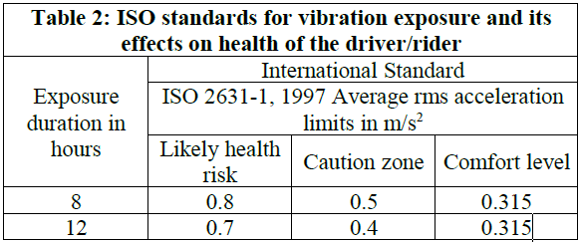

Vibrations with -

Less than 0.315m/s2 are found to be comfortable

Between 0.315m/s2 and 2.5m/s2 are found to be uncomfortable

Greater than 2.5m/s2 are found to be extremely uncomfortable.

**HOW TO MEASURE THIS PARAMETER?**

Measuring vibration involves quantifying the oscillations or movements of an object or system.

Vibrations are measures using various measuring devices :

* Accelerometer
* Gyroscope

**ACCELEROMETER** :

An accelerometer is a device that is able to measure a linear acceleration – motion along an axis, and also the rate at which linear velocity is changing with time. It is able to measure acceleration forces either static( force of gravity ) or dynamic( forces induced on the sensor by motion or vibration).

**TYPES OF ACCELEROMETERS :**

1. **Piezoelectric Accelerometers**

They utilize the piezoelectric effect, where certain materials generate an electric charge when subjected to mechanical stress.

1. **Piezoresistive Accelerometers**

These accelerometers use piezoresistive materials that change their resistance in response to mechanical stress.

1. **Capacitive Accelerometers**

Capacitive accelerometers measure changes in capacitance between two closely spaced plates. Acceleration causes a change in the distance between the plates, leading to a change in capacitance.

1. **IEPE Accelerometers**

These accelerometers combine a piezoelectric sensor element with built-in electronics, allowing them to provide a low-impedance voltage output directly proportional to the measured acceleration.

1. **MEMS (Micro Electro Mechanical Systems) Accelerometers**

These are a type of accelerometer that utilize microfabrication technology to create miniature sensors capable of measuring acceleration.

1. **Optical Accelerometers**

These accelerometers use optical principles to measure acceleration.

1. **Vibrating Structure Accelerometers**

These accelerometers involve a vibrating structure that changes frequency when subjected to acceleration.

1. **Proximity Probe**

These are non-contacting transducers that measure distance to a target.

**CHOOSING THE RIGHT ACCELEROMETER :**

1. **VIBRATION AMPLITUDE :**

Sensor range should be appropriate so as to prevent distortion of response.

Accelerometer Properties : monitoring high vibration level, low sensitivity, low mass.

1. **SENSITIVITY:**

* Use a low sensitivity accelerometer to measure high amplitude signals
* High sensitivity accelerometer to measure low amplitude signals.

1. **NUMBER OF AXES:**

It has two axial types:

Single Axis Accelerometer Tri Axes Accelerometer

To measure mechanical vibration levels

To determine type of vibration line : lateral, transverse, longitudinal

1. **WEIGHT:**

Weight of sensor should be less than the monitored structure. The weight should not be greater than 10% weight of test structure.

1. **MOUNTING OPTIONS:**

Four typical mounting methods:

* Handheld or probe tips
* Magnetic

these all are Temporary Attachments

It is best mounting technique & it is permanent sensor installation

* Adhesive
* Stud mount

Looser the connection, Lower the measurable frequency limit.

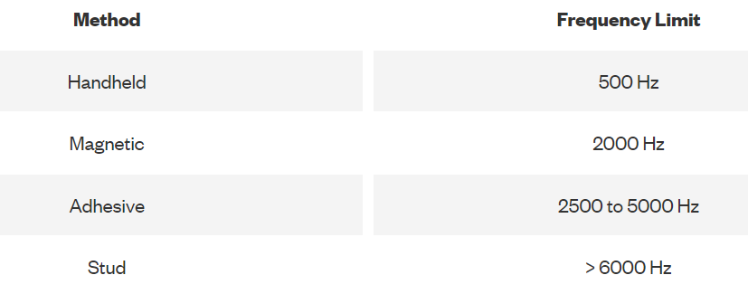

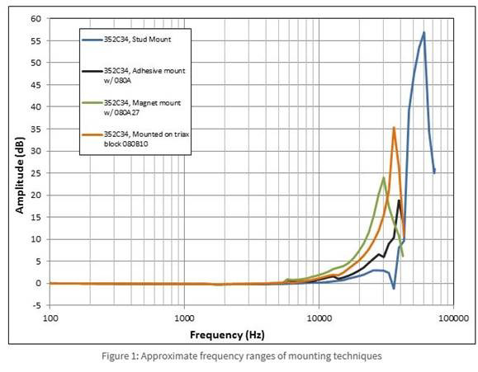

1. **ENVIRONMENTAL CONSTRAINTS:**

* For Extreme Temperature : Charge mode Accelerometer (Piezoelectric Accelerometer)
* For Noisy Environment : Inline Charge Converter or (IEPE sensor with built in charge amplifier)
* For Humidity Environment : Humidity specification are defined by type of seal on Accelerometer

Types of Seals:

* Hermetic (Fluid Immersion)
* Epoxy
* Environmental

1. **COST:**

IEPE is the most cost-effective accelerometer.

**SIGNAL CONDITIONING IN ACCELEROMETER :**

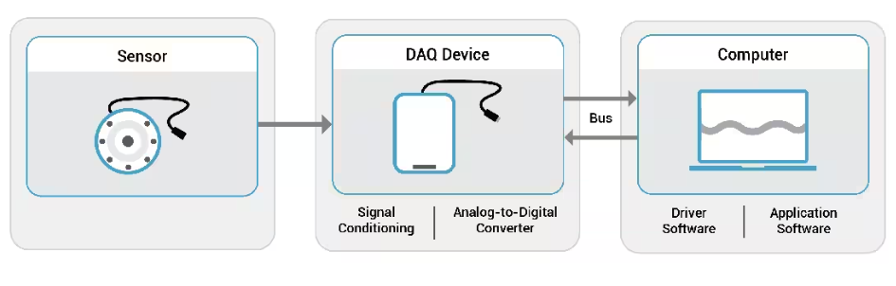

Data acquisition (DAQ) is the process of measuring an electrical or physical phenomenon, such as voltage, current, temperature, pressure, or sound. A DAQ system consists of sensors, DAQ measurement hardware, and a computer with programmable software.

**(Day -4)**

**ORTHOGONAL AXES TO BE CONSIDERED FOR VIBRATION CALCULATION :**

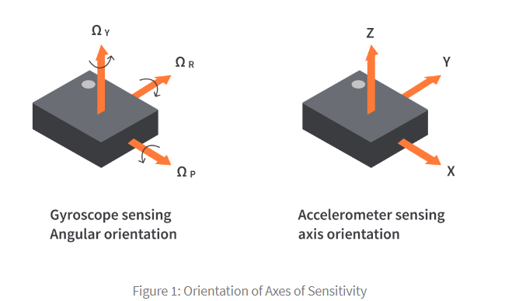

For vehicle vibration analysis, 3-Orthogonal axes corresponding to 3-D space represents the different direction in which vibration can occur.

|  |  |
| --- | --- |
| 1. **Longitudinal Axis ( X ) :**   Runs along the length of the vehicle.  Causes : Engine dynamics, road surface irregularities, vehicle acceleration and deceleration   1. **Lateral Axis ( Y ) :**   Runs along the width of the vehicle.  Causes : Turns, changes in road camber   1. **Vertical Axis ( Z ) :**   Runs perpendicular to the ground, from bottom to top of the vehicle  Causes : Road bumps, potholes & uneven surfaces | 1. **Pitch ( P ) :**   Causing rotation along X-axis   1. **Roll ( R ) :**   Causing rotation along Y-axis   1. **Yaw ( Y ) :**   Causing rotation along Z-axis |

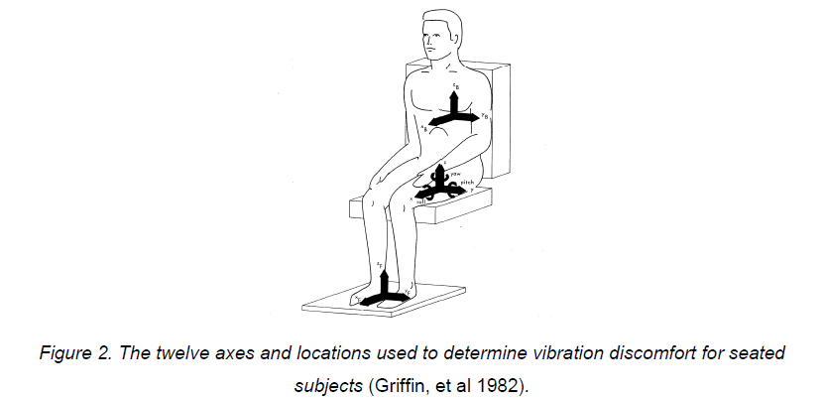

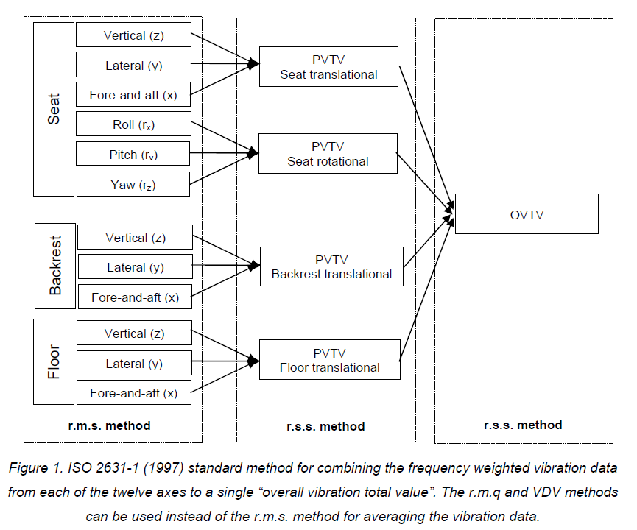

**WHICH ACCELEROMETER TO CHOOSE AND WHY ?**

We are choosing MEMS Accelerometer for the following reasons :

* widely used in Embedded System for vibration analysis
* small size
* low power consumption
* cost effectiveness
* can measure both static and dynamic accelerations
* available with varying sensitivity & frequency ranges.

In what cases might the MEMS accelerometer data can get effected ?

ChatGPT

MEMS (Micro-Electro-Mechanical Systems) accelerometers are commonly used to measure acceleration in various devices, including smartphones, wearables, automotive applications, and industrial equipment. However, their data can be affected by various factors that might introduce inaccuracies or errors into the measurements. Here are some cases in which MEMS accelerometer data can be affected:

1. **External Vibrations and Shocks:** Vibrations and shocks from the device's surroundings, such as during transportation, machinery operation, or even just placing the device on a vibrating surface, can introduce unwanted acceleration readings. This is particularly significant in industrial or automotive applications.
2. **Mechanical Noise:** MEMS accelerometers are sensitive to mechanical noise, which can arise from the device's housing, connectors, or other components. This noise can lead to inaccuracies in acceleration measurements.
3. **Temperature Variations:** Extreme temperature variations can affect the performance of MEMS accelerometers. They might experience thermal expansion and contraction, which can alter their sensitivity and accuracy. Some accelerometers are equipped with temperature compensation mechanisms to mitigate this effect.
4. **Electromagnetic Interference (EMI):** Electromagnetic fields generated by nearby electronic devices can interfere with MEMS accelerometer readings. EMI can lead to erratic or biased acceleration measurements.
5. **Power Supply Variations:** Fluctuations in the power supply to the accelerometer can impact its performance. Inconsistent power can affect the stability and accuracy of the sensor's output.
6. **Aging and Wear:** Like all mechanical devices, MEMS accelerometers can experience wear and aging over time. This can lead to changes in their sensitivity, accuracy, and overall performance.
7. **Cross-Axis Sensitivity:** MEMS accelerometers might have some sensitivity to acceleration in directions other than their primary axis of measurement. This can lead to cross-axis interference and inaccurate readings.
8. **Mounting and Orientation:** The orientation in which the MEMS accelerometer is mounted can affect its measurements. Mounting it at an angle or in an incorrect orientation can lead to inaccurate readings.
9. **Calibration Drift:** Over time, the calibration of the accelerometer might drift, causing its measurements to deviate from the true values. Regular calibration is necessary to maintain accurate readings.
10. **Harsh Environments:** In environments with high levels of dust, moisture, chemicals, or other contaminants, MEMS accelerometers might be exposed to conditions that can affect their performance and longevity.
11. **Microphonics:** Vibrations or sound waves (acoustic noise) can create electrical signals within the accelerometer due to its mechanical structure. These unintended signals can interfere with the acceleration measurements.

To mitigate these effects, manufacturers often implement various techniques, such as filtering, shielding, temperature compensation, and calibration routines. Users of devices with MEMS accelerometers should also be aware of these potential sources of error and take appropriate measures to minimize their impact on data accuracy.

MPU is the MPU6050, MPU stands for Motion Processing Unit.